Family Systems Resources
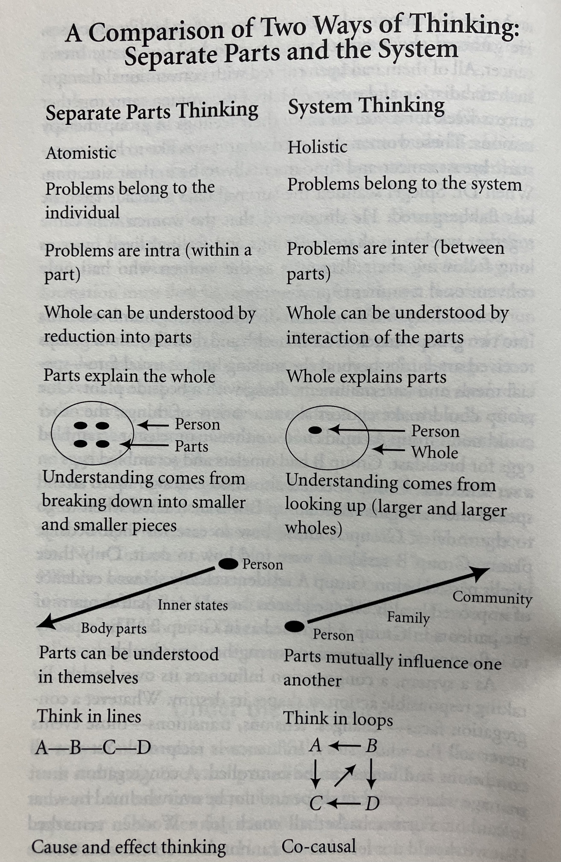

Helpful web source: https://www.thebowencenter.org/introduction-eight-concepts

Clergy Focused Congregations
- Excessive focus on clergy (difficult to think of the rest of the system); overinvested in clergy (“hero or goat”); clergy primarily responsible for what happens
- Dependency encouraged (parent/child arrangement); no activity without clergy present
- Neediness in enabled

- Clergy expected to motivate, uplift, or rescue people
- Inflexible roles (survival depends on a prescribed way of functioning)
- Cycle of emotional fusion (lack of “distance”; clergy not seen as separate individuals; clergy are “owned”)
- “We” (very few speak for themselves); allow inappropriate behavior to exist, no one confronts or speaks up
- “Consensus sensitive” (difference is seen as attack, can’t survive if we don’t agree); clergy is hub of harmony
- Disagreement is dangerous (calm surface)
- Closed system (lack of “oxygen,” no corrective feedback, novelty is not entertained)

Mission-Focused Congregations
- A clear focus on identity and destiny

- Stewardship emphasized; responsibility is distributed; interdependence
- Needs are met without promoting dependency

- Clergy expected to organized people toward mission
- Resiliency in functioning

- Clergy are separate selves; clergy set goals and take stands

- “I” positions are respected; lots of dialogue (physicist David Bohm says, “Dialogue means not winning points”)

- Vision sensitive (differences are tolerated because vision guides and solidifies people)
9. Conflict is normal, essential, and managed
10. Open system (lots of information, new ideas, feedback loops)

